

**STRATEGIC FORECAST & PLAN**

**Luis F. Mireles**

**lmireles2@leomail.tamuc.edu**

**Texas A&M Commerce**

**4/26/2020**

**Table of Contents**

Executive Summary 3

Objective & Methodology & Hypothesis 4

P&G characteristics analysis & hypothesis testing 5

Forecasts for Export: Value Goods & Revolving Consumer Credit 10

Regression Analysis 14

Pro-Forma Plan 18

Program Recommendations & Data 19

Appendix 20

References 23

**STRATEGIC FORECAST & PLAN – EXECUTIVE SUMMARY**

The following plan incorporates the use of a regression analysis testing the x variables “Export: Value Goods” & “Revolving Consumer Credit” & categorical variables: “Recession”, “Low Advertisements”, and “New Product Sales”. The models first test the correlations and general statistics to see how reliable, accurate and reasonable all these variables are. The best forecast analysis is chosen for each x variable to be used in the regression analysis. The forecast is analyzed, and the categorical values are turned on at specific dates relevant to them and the forecast fluctuations to capture as much data as possible. The model is put through several tests to check for heteroscedasticity, serial correlation, seasonality, accuracy, reliability, and visual reasonableness.

After meeting high levels of confidence in these measures the forecast is run using regression analysis with the mentioned x variables & categorical variables. The company revenue forecasted includes a negative categorical value turned on for the last 3 quarters of 2020 (Low Ads) to show negative impact that is expected from the coronavirus pandemic. The forecast produced is included in the pro-forma plan with the new updated numbers of importance such as stock, EPS, etc. Two programs are recommended after the analysis which are the entering of an emerging market with a 15% target and a 5% cut in sales general and administrative expenses. The regression forecast for next 8 quarters without the implementation of the programs results in $ -332.82 million average loss per quarter, $ -67.71 million average loss in income per quarter, and $ -2.14 average loss in stock price per quarter. The regression forecast with implementation of the programs results in $ -43.17 million average loss per quarter, $ -9.36 million average loss in income per quarter, and $ -0.29 loss in stock price per quarter.

**Objective & Methodology**

Objective is to develop the best two year quarterly forecast for Procter & Gamble revenue and pro-forma plan.

First, the creation of a hypothesis on several macroeconomic variables that are believed to have a logical influence on Procter & Gamble revenue (Y) and will be relevant to its characteristics of trends, cycles and seasonality if applicable. There will be testing of the hypothesis using first a scatter plot using regression to see if there is a significant slope visible between the company revenue and the x variables. The analysis will be followed by a correlation test to confirm there is a high correlation between the (Y) Procter & Gamble revenue and the (X) macroeconomic variables chosen.

After the correlation confirming high Procter & Gamble revenue (Y) to macroeconomic variables (X) there will be a test of the hypothesis with early regression Y=a + B1X1 + B2X2. Then a forecast for each variable will be made using historical data with three approaches (Expo smoothing, decomposition, ARIMA). Then selection of the best forecast of each (X) variable from these methods and revision of the early regression model to best fit the Procter & Gamble revenue and testing of the model. Then the use of the regression forecast with the Procter & Gamble company 10k to create a pro-forma financial strategic plan. Lastly, a comment on the plans financial results and recommendations for Procter & Gamble’s performance improvement.

**Hypothesis**

Procter & Gamble Revenue = f (Export: Value Goods + Revolving Consumer Credit + New Product Sales + Recession + Low Advertisements)

Procter & Gamble sells nondurable consumer goods as their main source of revenue so if revolving consumer credit changes it should be affecting the revenue for Procter & Gamble as the more credit consumers have the more purchases of our higher quality and higher priced products than cheapest brands should happen. Procter & Gamble sells products all over the world so if the Export: Value Goods economic data increases it should have a positive correlation to Procter & Gamble Revenue as it will mean we will also be exporting more of our product. The recession will be significant to make the forecast as well as a low advertisement period and the new product sales period. These categorical variables will be useful for the final regression model and forecast.

X Variables:

*Exports: Value Goods for the United States, National currency, Monthly Level, Quarterly, in Millions $ Not Seasonally Adjusted* // Shown as: “Export: Value Goods”

*Households and nonprofit organizations; revolving consumer credit; liability, Level, Millions of Dollars, Quarterly, Not Seasonally Adjusted* // Shown as: “Revolving Consumer Credit”

**P&G characteristics analysis & hypothesis testing**

This is the analysis to see the characteristics of Procter & Gamble Revenue and the testing of the x variables from the hypothesis to ensure that they are true at the 95% confidence level.

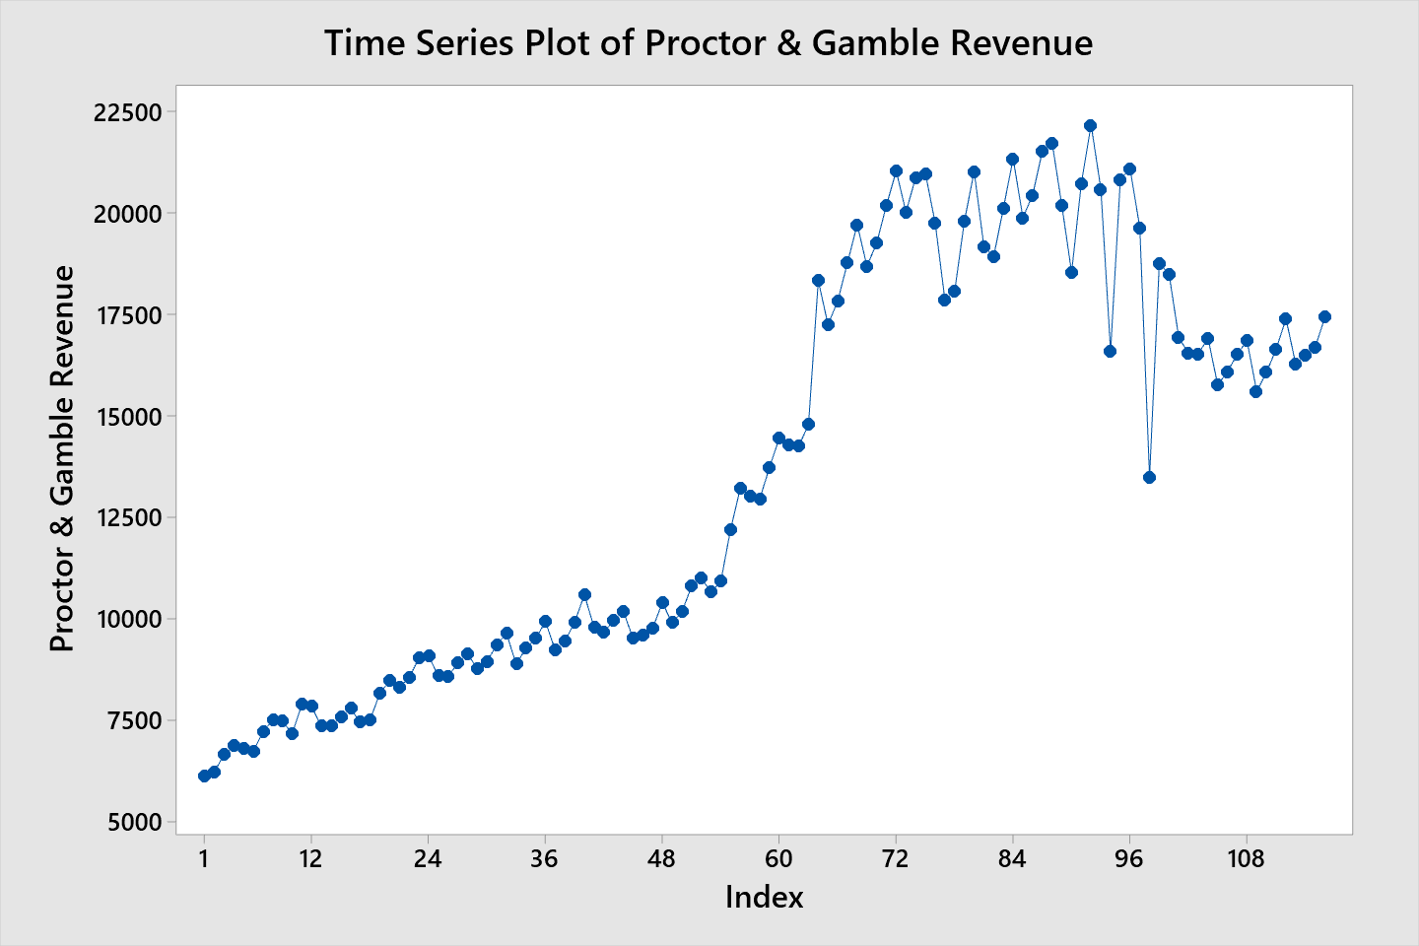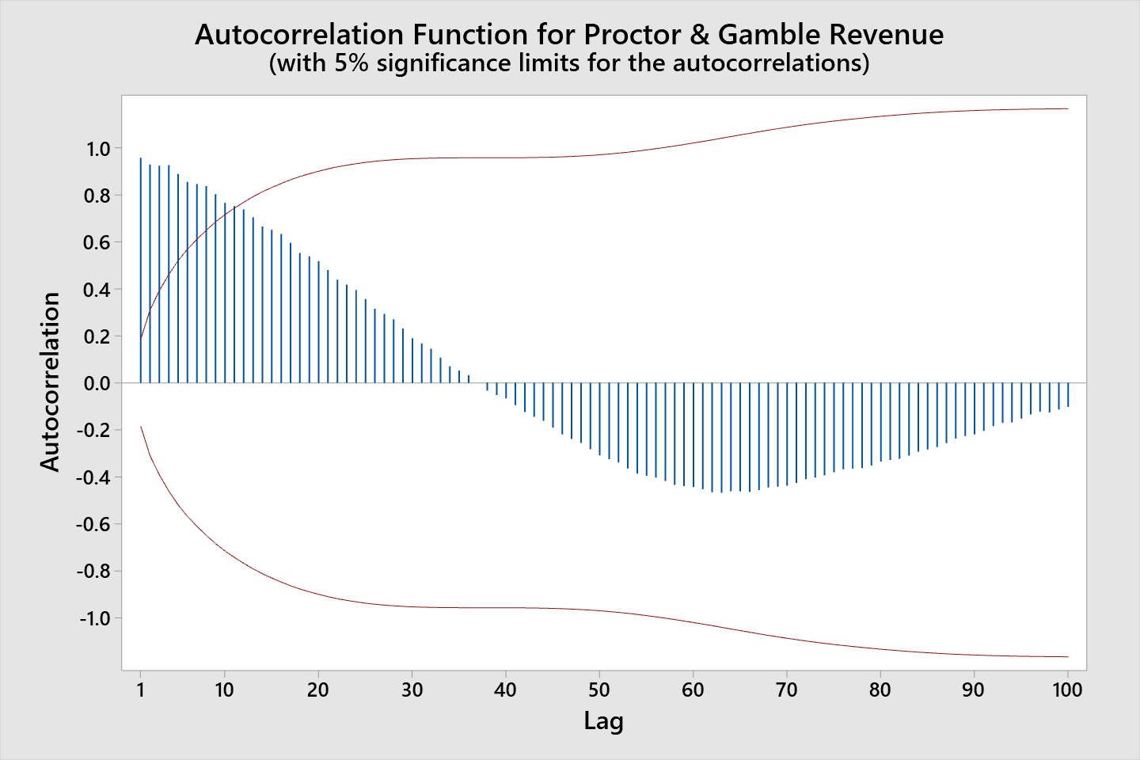

The time series plot for Procter & Gamble revenue shows an upward trend while having the cycle characteristic. Running the autocorrelation on Procter & Gamble gives us the indicator that it is seasonal as the average of the 3rd and 5th lag is 0.905 and the 4th lag is 0.923 showing statistically significant seasonality which will be taken into consideration for the forecast.

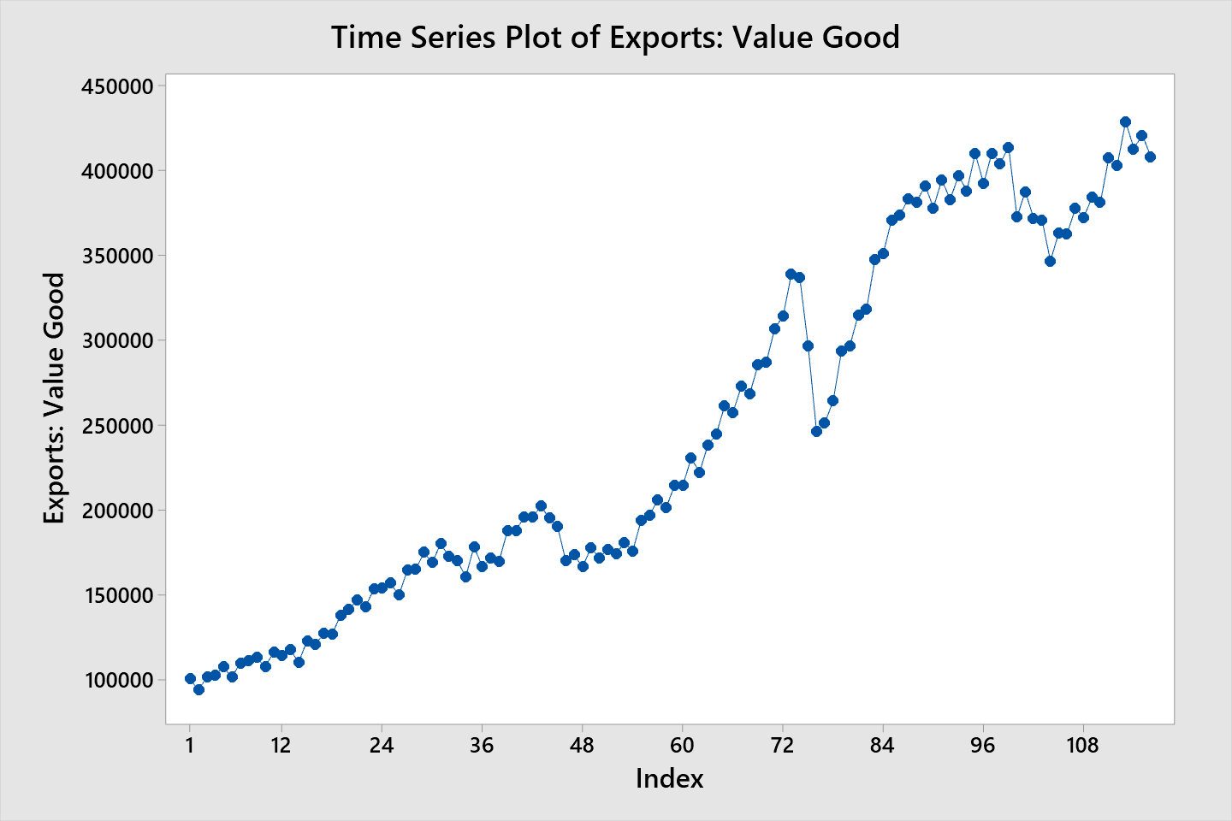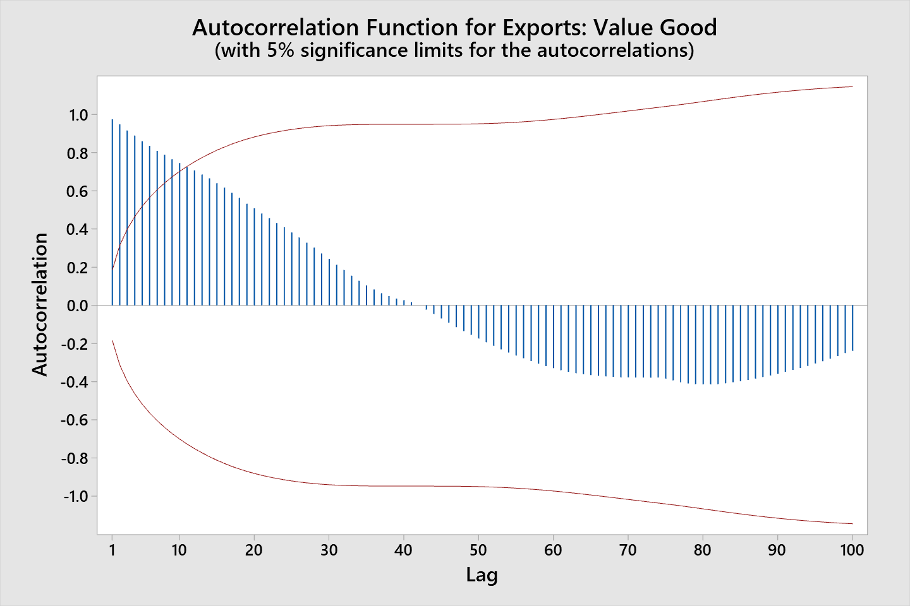

The time series plot of Exports: Value Goods shows significant similarity to the time series plot of Procter & Gamble revenue with a similar upward trend. This X variable shows trend and cycle characteristics and upon running the autocorrelation function to find seasonality the 3rd & 5th lag average is 0.88 compared to the 4th lag which is 0.88 (rounded 2 decimals) showing no seasonality for this x variable.

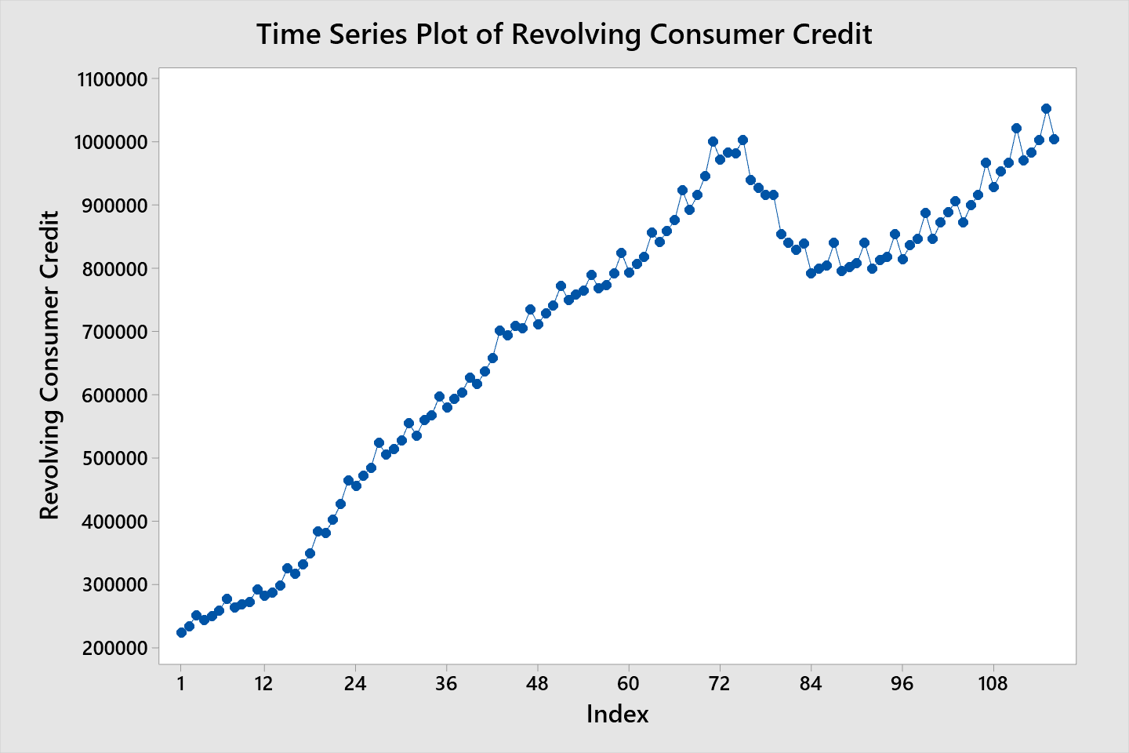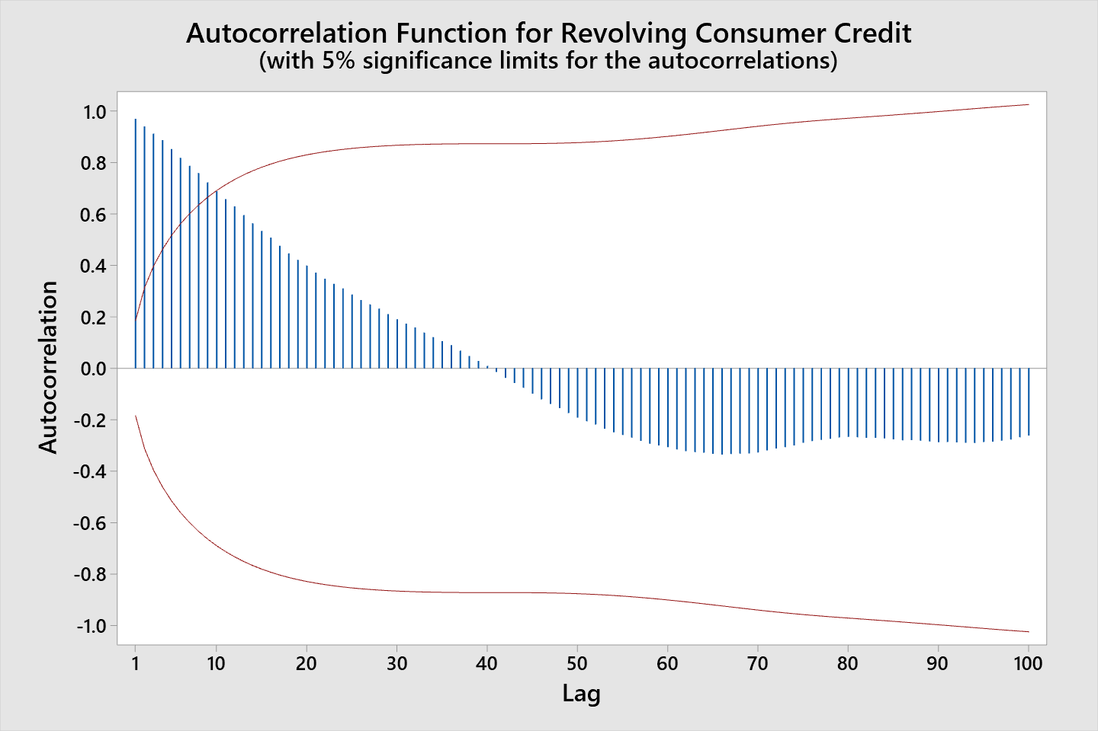

The time series plot of Revolving Consumer Credit shows significant similarity to the time series plot of Procter and Gamble revenue with a similar upward trend. This X variable shows trend, cycle, and seasonality characteristics as shown in the time series plot and upon running the autocorrelation function to find seasonality the 3rd & 5th lag average is at 0.88 compared to the 4th lag which is at 0.89 (rounded 2 decimals) confirms the seasonality for this x variable.

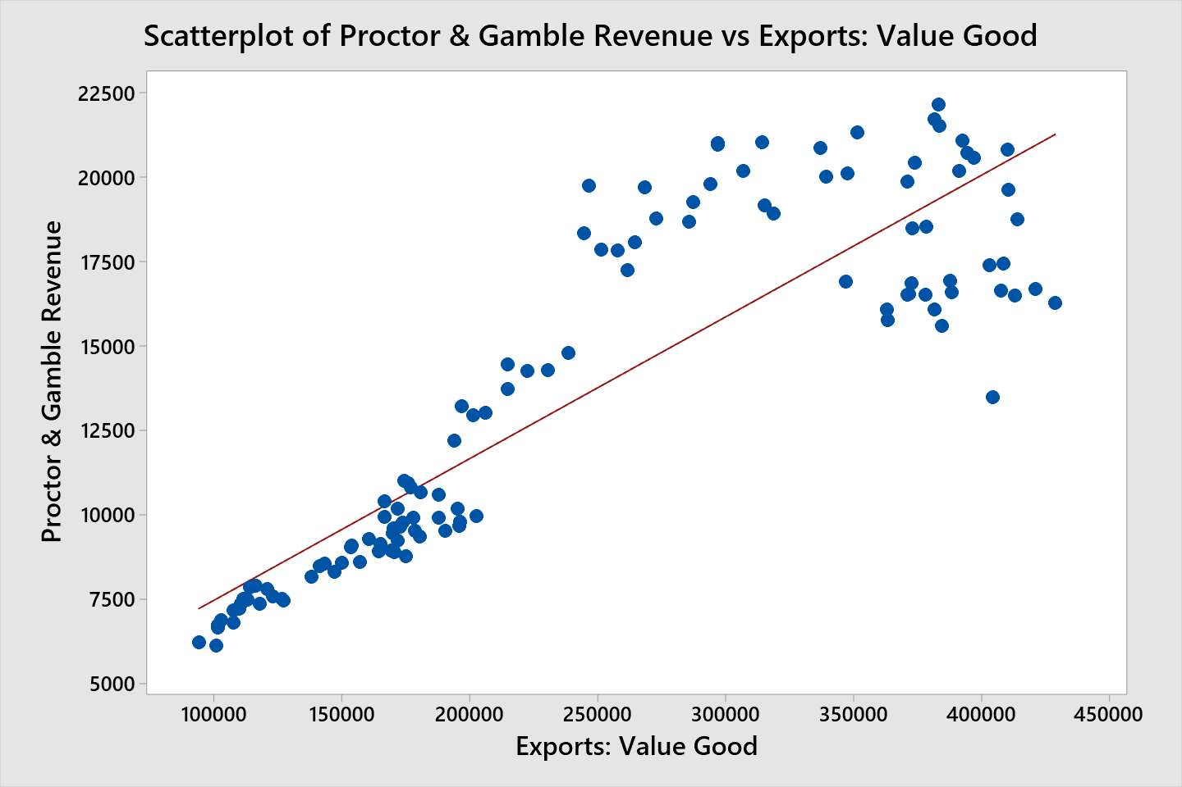

There is a strong upward slope in the scatterplot between Procter & Gamble revenue and Exports: Value Good which indicates high sensitivity & response to each other. There is some minor heteroscedasticity in this relationship as the scatter tends to widen and depart from regression line at the right side of the plot.

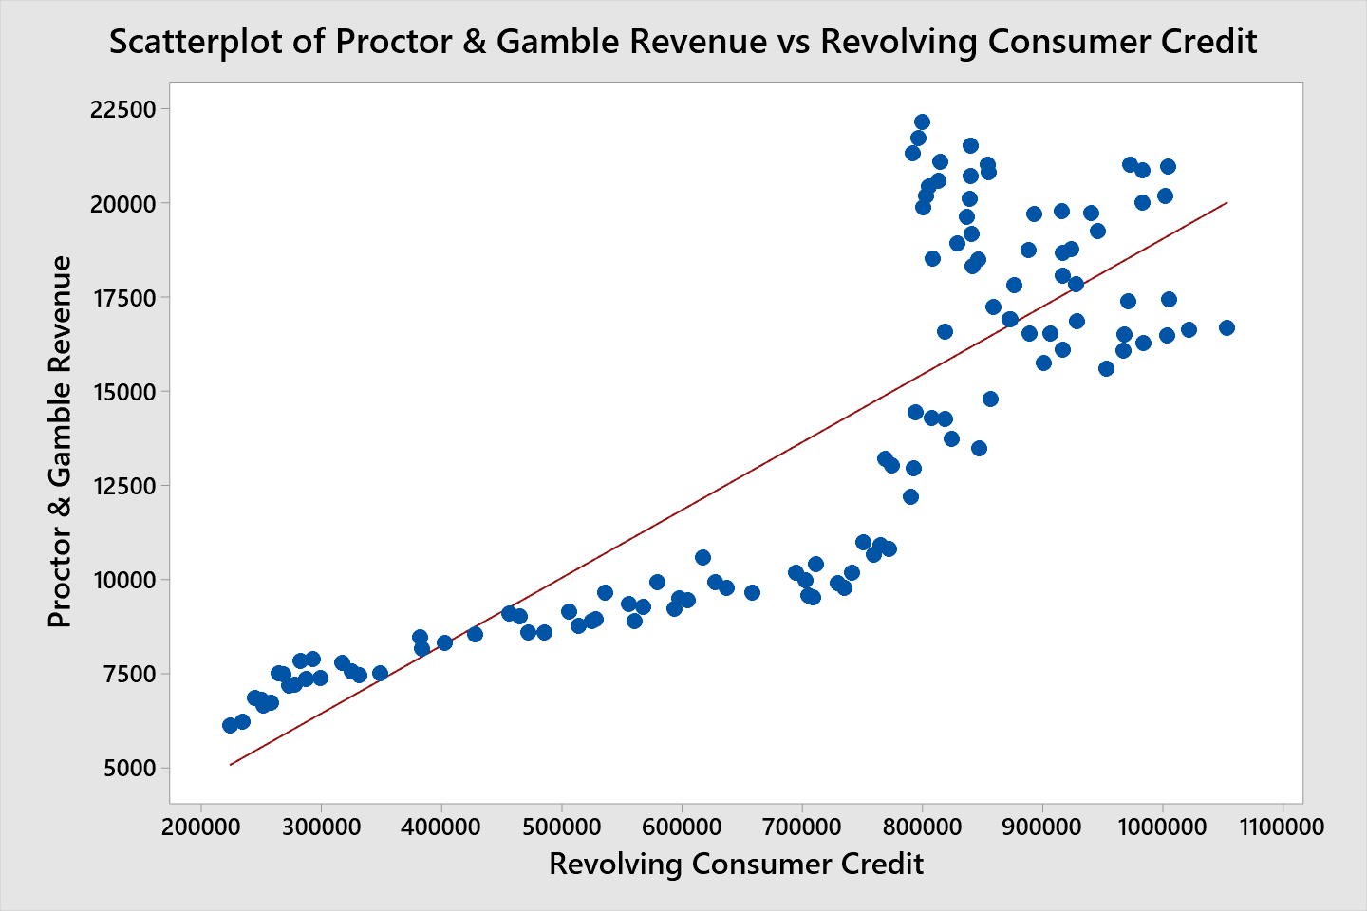

There is a strong upward slope in the scatterplot between Procter & Gamble Revenue and the Revolving Consumer Credit indicating high sensitivity & response to each other. There is minor heteroscedasticity in this relationship as the scatter widens a minor amount and departs from the regression line towards the right of the plot, but it comes back closer again in the end of the regression line.

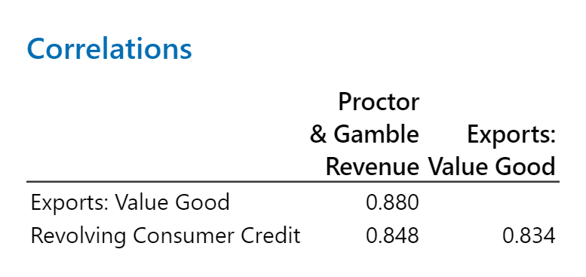

Running the correlation test for Exports: Value Good & Revolving Consumer Credit there is a highly significant correlation for Exports: Value Good at 0.880 and 0.848 for Revolving Consumer Credit which is higher than the correlation the x variables have to each other passing correlation test requirements.

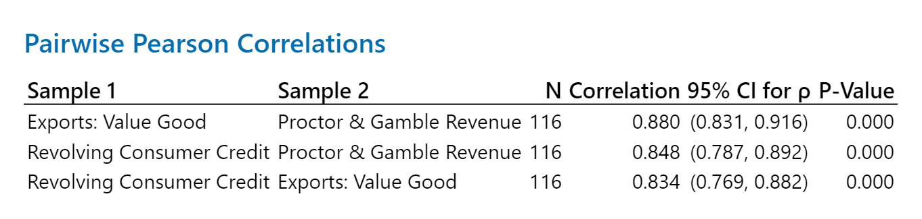

The pairwise pearson correlations show a P-Value of 0.000 confirming these x variables can be used and that we have higher than 95% confidence level.



The regression equation shows that for every increase of 1 million US dollars in Revolving Consumer Credit the company revenue increases by $7,930 US dollars and that for every increase of 1 million US dollars in Exports: Value Good the company revenue increases by $27,160 US dollars.

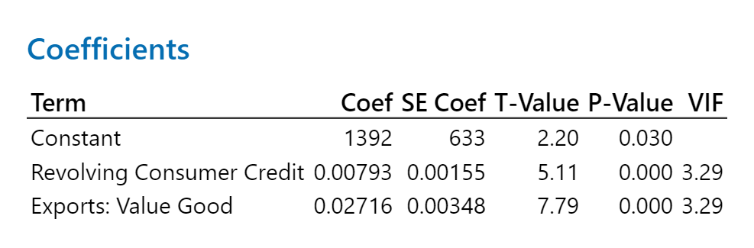

The statistical results of the regression analysis have the coefficient value for both variables staying positive which is consistent with the correlation signs. The T-Value for both X variables is over the 1.96 absolute value threshold showing high statistical of evidence against the null hypothesis. The P-Values are at 0.000 which are lower than the 0.05 showing these X variables have a high confidence level and belong in the forecast. The VIF is below 5 at 3.29 for both X variables to support that we do not have multicollinearity.

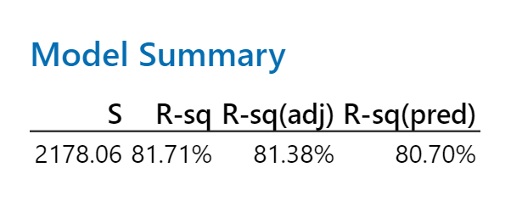

In model summary the result for the R-sq (adj) is high at 81.38% showing that the x variables are effective & benefit the model and that the model has good reliability.

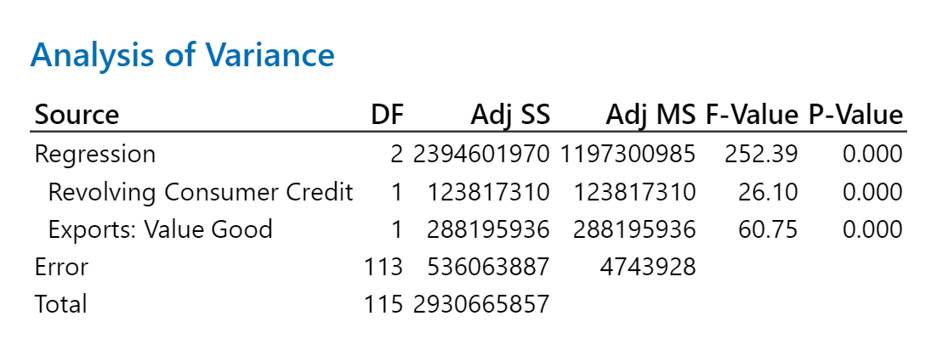

On the analysis of variance, the F-value is high at 252.39 for the regression showing that the test is statistically significant with the Exports: Value Good & the Revolving Consumer Credit variables showing the model has reliability.

This analysis shows that the hypothesis with these two x variables is true at the 95% confidence level and the statistics show that the model is reliable.

**Forecasts for Export: Value Goods & Revolving Consumer Credit**

ARIMA Forecasts

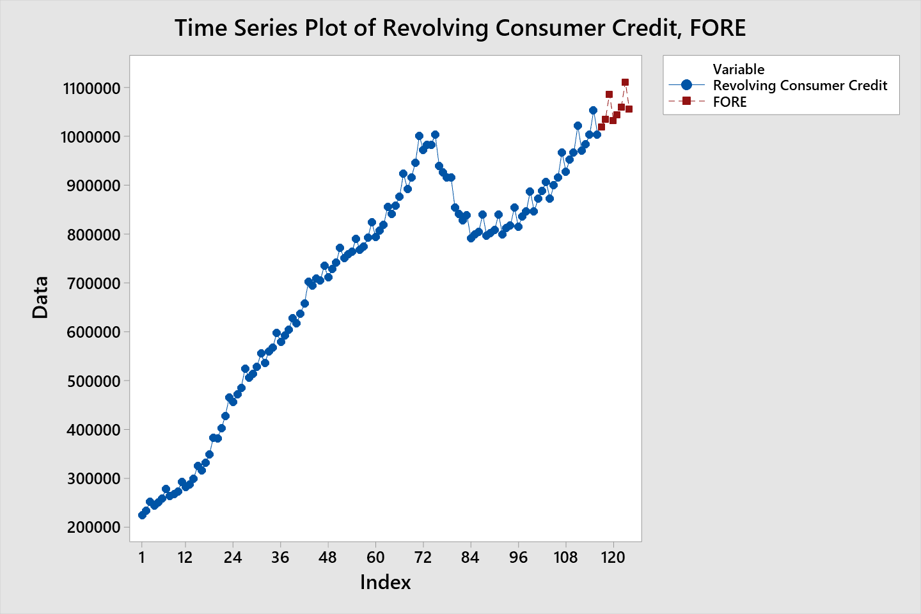

The time series plot of X variable Revolving Consumer Credit with the 8-period ARIMA forecast shows significant reasonableness with the historical data as it follows the direction of the trend and continues the spikes of seasonality.

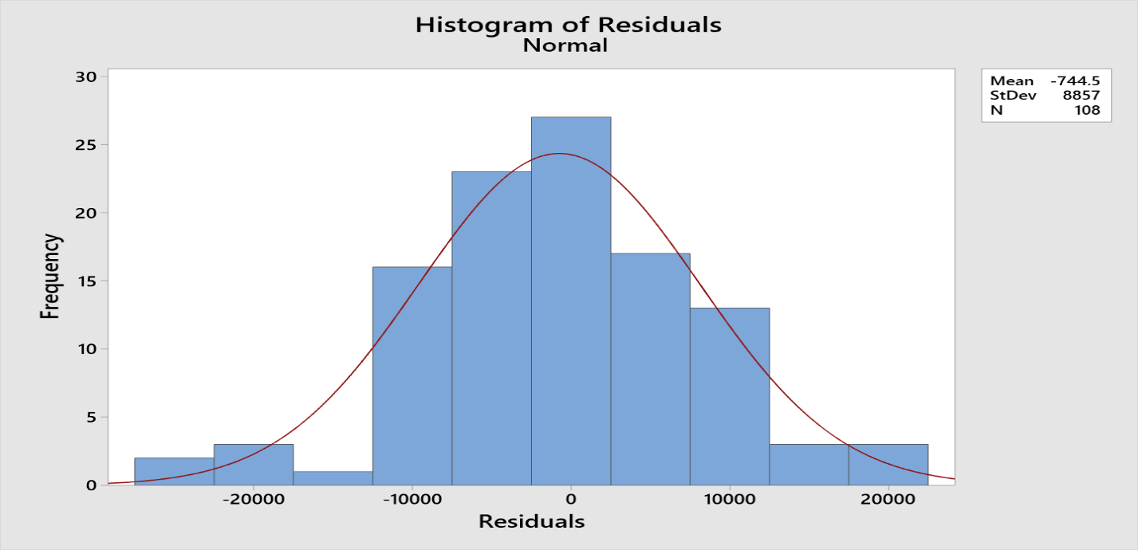

The histogram analysis of the residuals shows a mean that is of reasonable size relative to the data and with it being a negative mean we can know the model will overestimate a small relative amount. The data is near normal distribution to prove some randomness with a minor skew to the right.

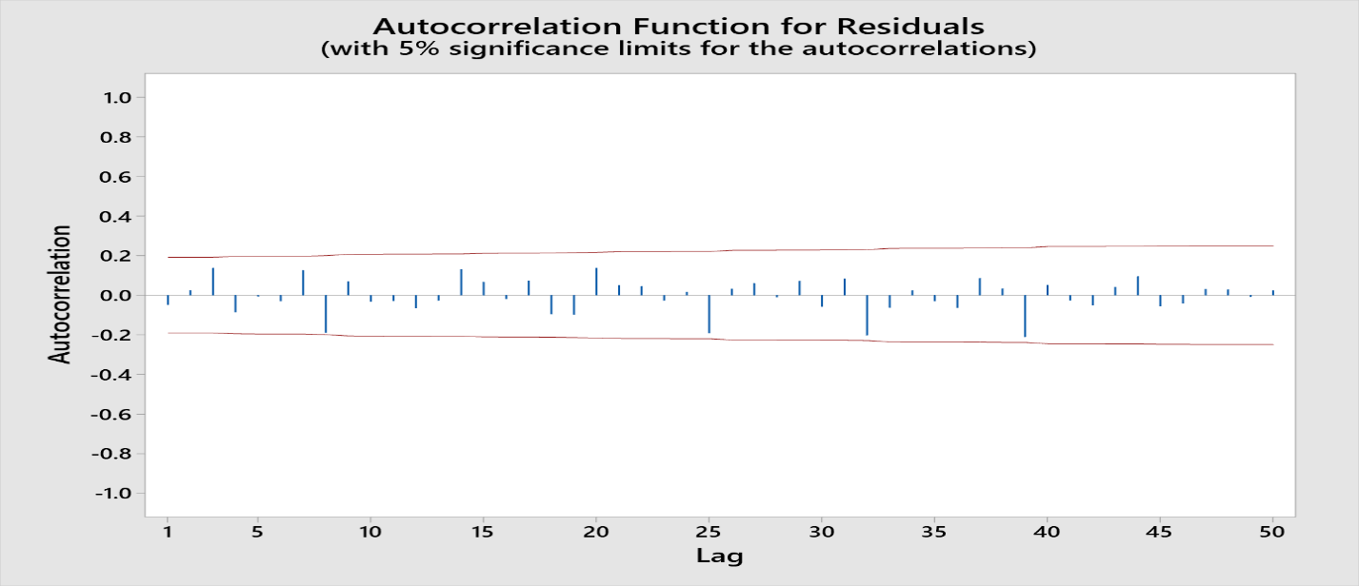

The autocorrelation function for the residuals show that the model is picking up the data and the residuals are random. LBQ values at 12th- 10.96 & 24th- 20.42 are significant and are showing the model is reliable.

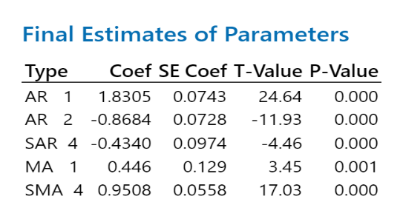

The Final Estimates of Parameters show the reliability of the model with significant T-Values for all AR and MA model types being over the 1.96 absolute value. P-values are significant below 0.05 for 95% confidence level.

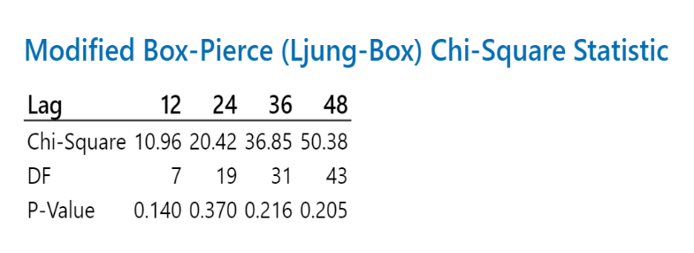

The Chi-Square statistics show the reliability of the model with the 12th lag being under required 21 at 10.96 & the 24th lag being under required 36.4 at 20.42.

**Accuracy Details:**

**MAPE: 0.0093251 or 0.9%** (rounded & turned into percentage)

**RMSE: 8847.04**

The MAPE is below preferred 5% at 0.9% which shows high accuracy of model statistics. The RMSE shows a reasonable standard deviation of residuals showing confidence in model accuracy.

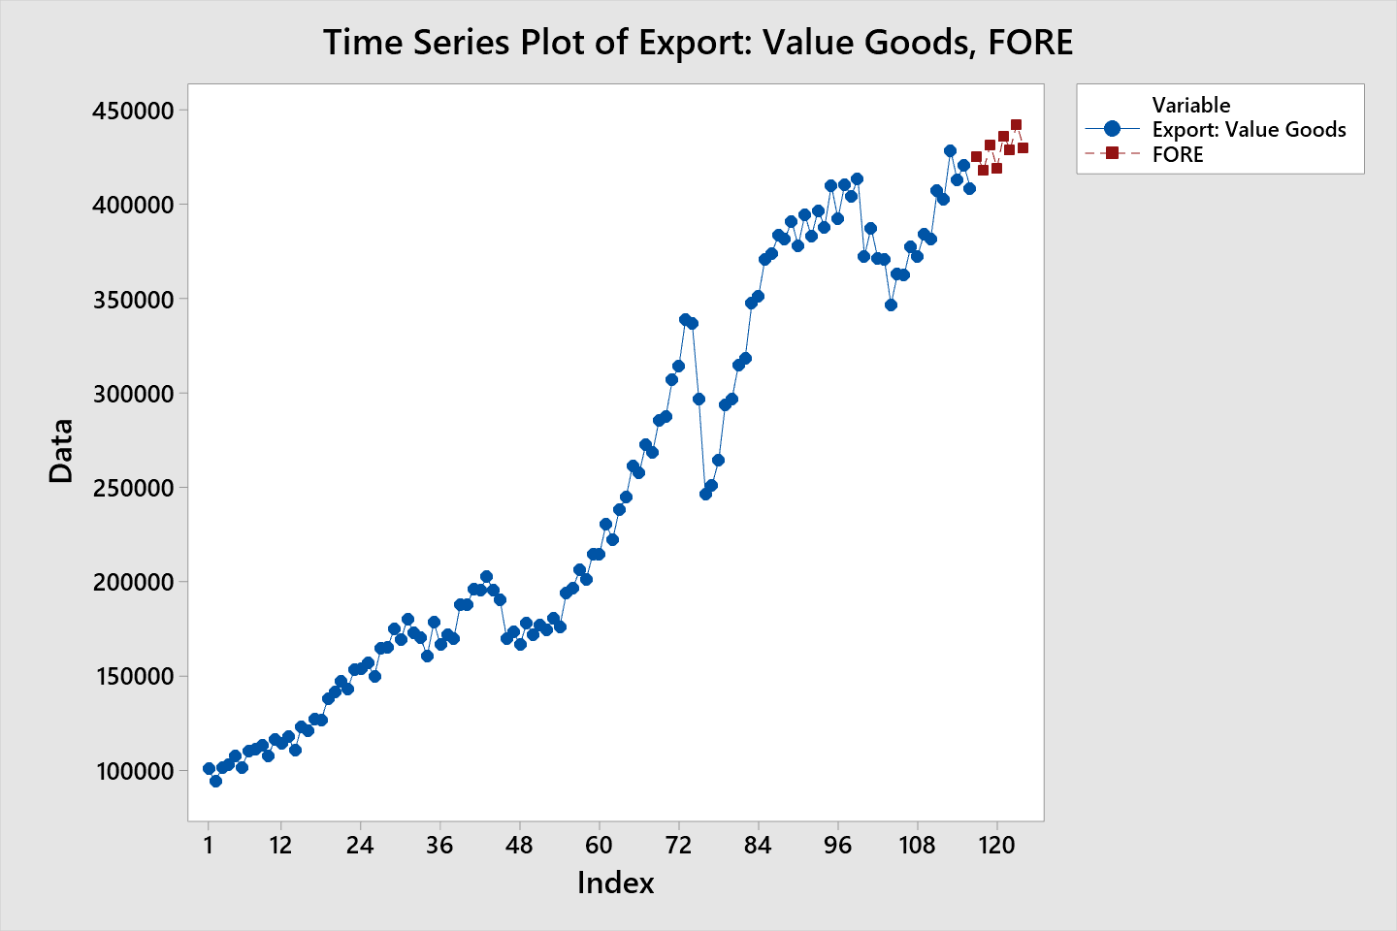

The time series plot of X variable Export: Value Goods with the 8-period ARIMA forecast shows significant reasonableness with the historical data as it follows the direction of the trend.

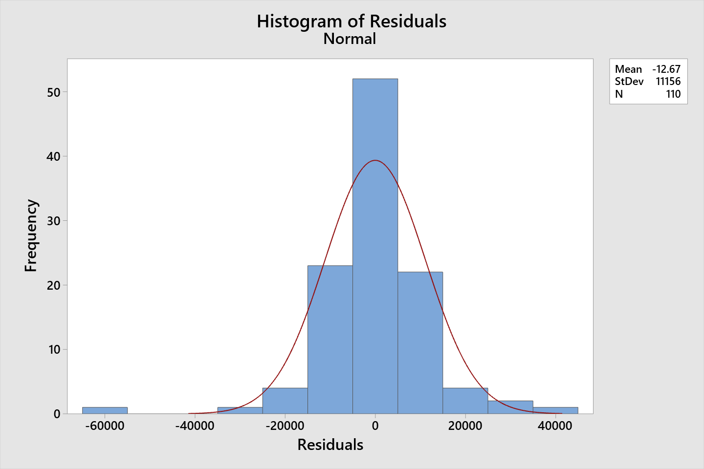

The residuals with a mean close to 0 relatively being a very small negative number suggesting little overestimation and a histogram that shows little to no skew to either side reinforces that this is both a random normal distribution.

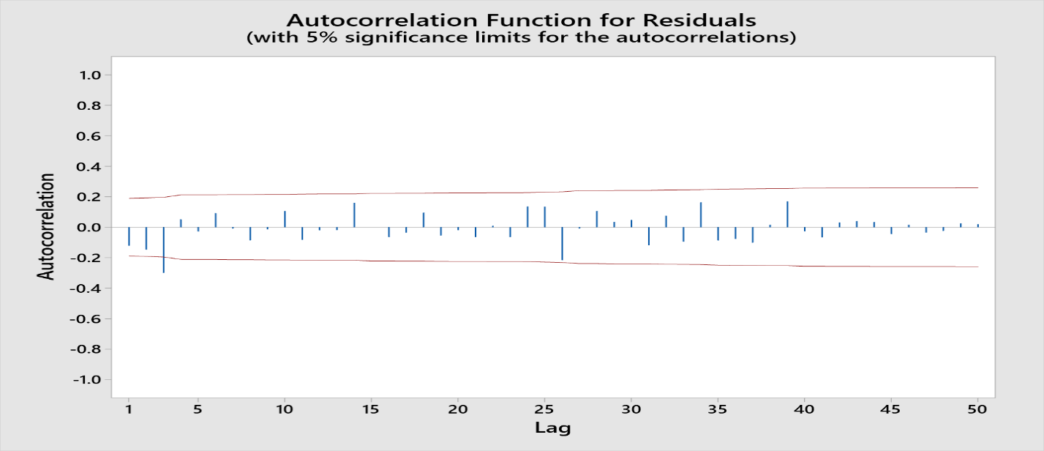

The autocorrelation function for the residuals show that the model is picking up the data and the residuals are random with only one lag excluded. LBQ values at 12th- 19.10 & 24th- 28.65 are significant and are showing the model is reliable.

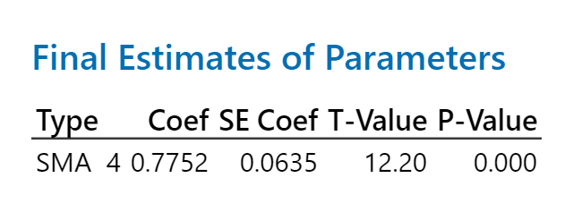

The Final Estimates of Parameters show the reliability of the model with significant T-Values for the MA model type being over the 1.96 absolute value. P-value is significant at below 0.05 for a 95% confidence level.

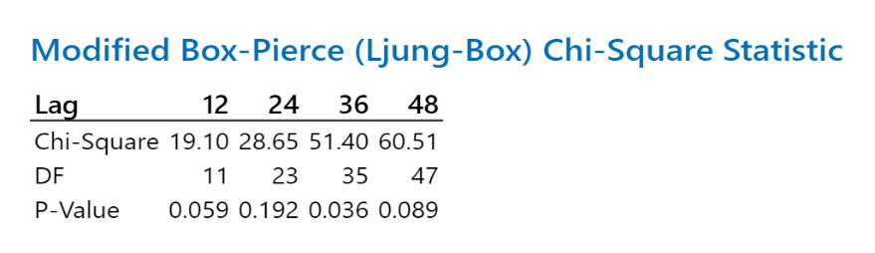

The Chi-Square statistics show the reliability of the model with the 12th lag being under required 21 at 19.10 & the 24th lag being under required 36.4 at 28.65.

**Accuracy Details:**

**MAPE: 0.0283126 or 2.8% (Rounded & turned into percentage)**

**RMSE: 11105.3**

The MAPE is below preferred 5% at 2.8% which shows high accuracy of model statistics. The RMSE shows a reasonable standard deviation of residuals showing confidence in model accuracy.

Conclusion on forecasts:

The statistics for the ARIMA forecast meet the statistical requirements needed in both accuracy and reliability as shown in accuracy details, chi-square, and field estimates of parameters in both x variables. The time series data with the forecast also meets reasonableness in the visual time series graph showing the 8 forecasted periods. Through all 3 measures of accuracy, reliability, and reasonableness with this data we can see the ARIMA forecast would give us high statistical confidence to use.

**Regression Analysis**

This is the regression analysis with the reliability, and accuracy statistics & charts to show that there can be confidence in the reasonable company revenue forecast throughout the 8 periods forecasted with this model.

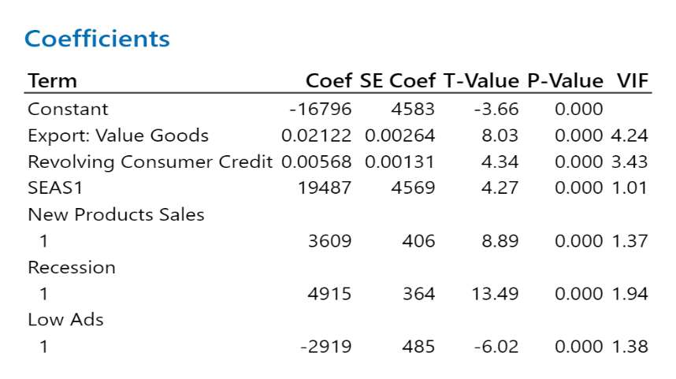

All variables have significant T-values, P-values, and VIF showing the reliability of the model. Statistics show that there is no multicollinearity and that we can have confidence in the model.

Coefficients show gains in millions of US dollars at a 0.02122 increase in revenue for every increase of Export: Value Goods and 0.00568 increase in revenue for Revolving Consumer Credit increases.

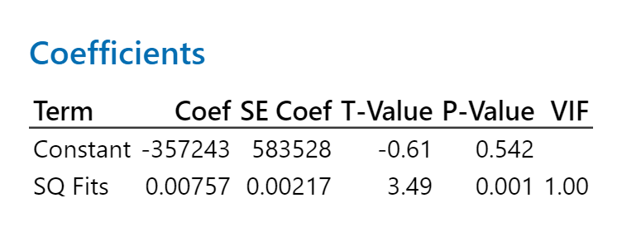

The KB test shows square fits as the continuous predictor to the square residuals that there is heteroscedasticity in the model as the T-value is significant at 3.49 this lowers reliability in the model but there is still high confidence in the model considering all other statistics on reliability.

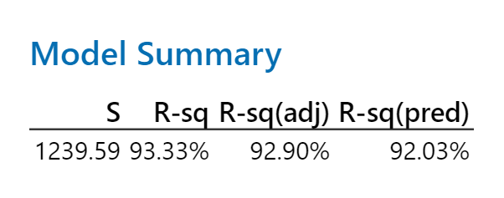

R-sq(adj) shows the analysis model is capturing 92.90% of data necessary showing this model has good reliability.

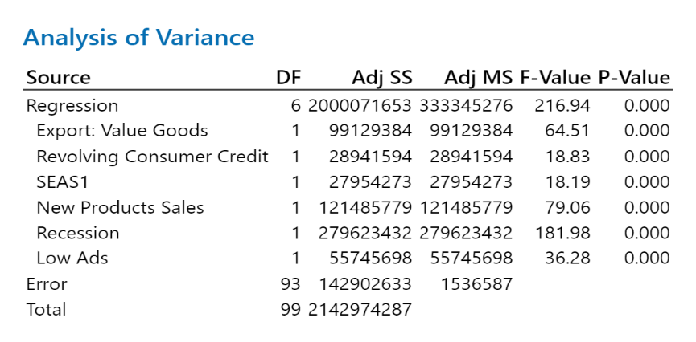

F-Value for regression is 216.94 showing good reliability and integrity of the regression model.

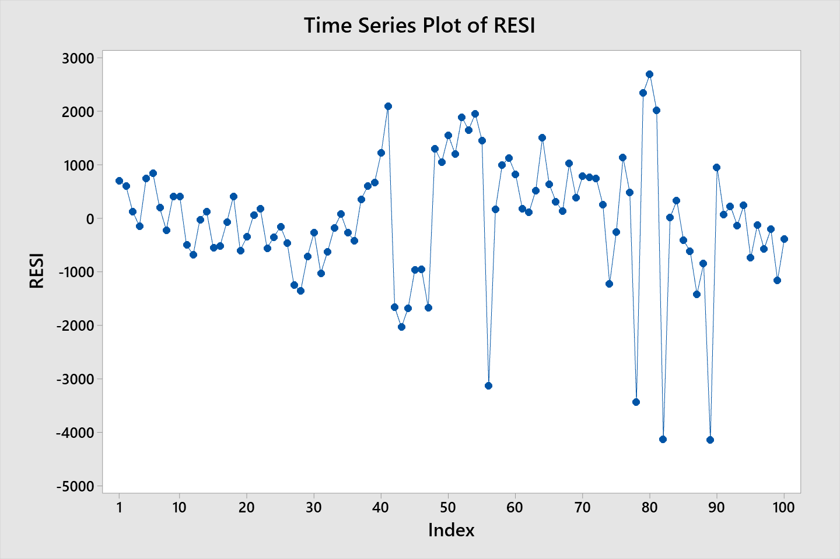

Time series plot of residuals showing how the model absorbed most of the cycle and seasonality using the regular x variables and the 3 categorical variables (recession, low ads, new product sales). Low ads variable turned on at 9/30/2013-12/31/2015, New product sales variable turned on at 6/30/2004-12/31/2007, and Recession variable turned on at 12/31/2007-3/31/2016.

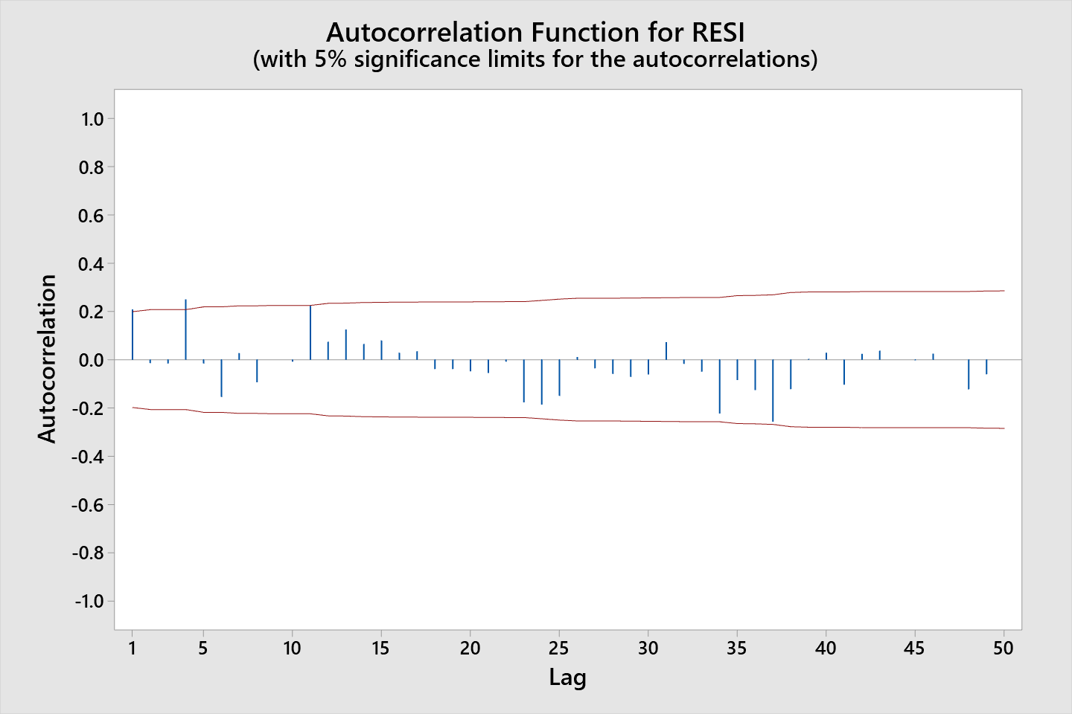

Autocorrelation shows mostly random distribution with almost all lags within the red meaning the model absorbed and was efficient with the data. LBQ values are statistically significant at 24th-34.36 & 12th-21.14 showing the model didn’t leave significant information out and has high reliability.

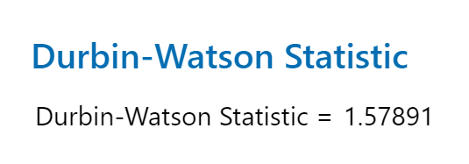

The Durbin-Watson statistic is showing that we do not have serial correlation in this model. The model will be estimating both cycle and seasonality appropriately and has high reliability.

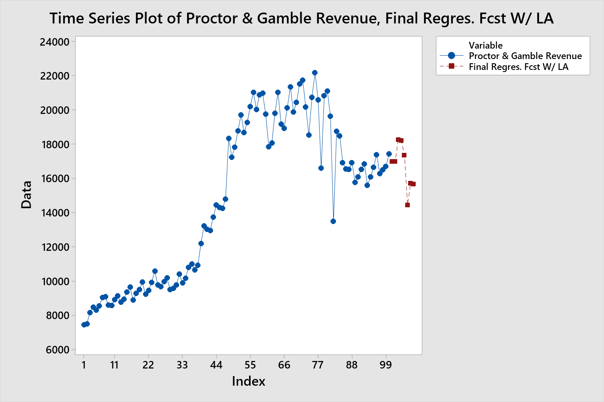

Regression analysis forecast considering the current situation with the coronavirus having a negative impact on company revenue throughout the last 3 quarters of 2020 the analysis shows high reasonableness. Low ads categorical variable turned on in Q2, Q3, Q4, of 2020 forecast to help predict the down curve of the coronavirus as it was the strongest negative variable.

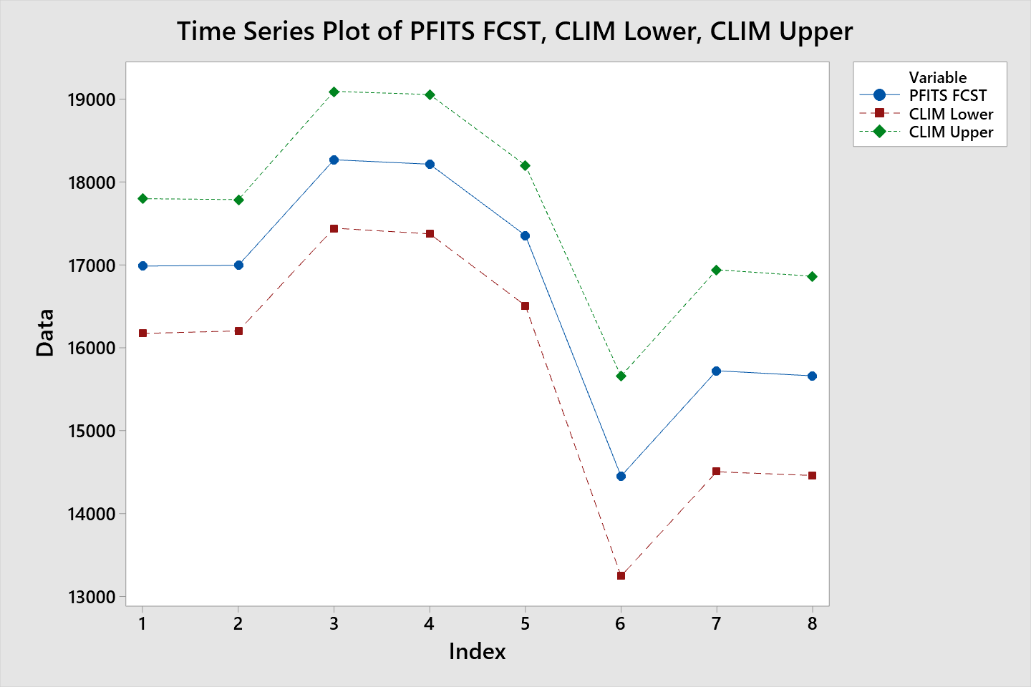

The time series plot with the lower and upper confidence levels of the forecast showing constant reasonableness throughout each forecasted period with a slight widening of the confidence interval over the forecast indicating a slight loss in forecast reliability over the plan.

**MAPE of model: 0.058 or 5.8%** at this error number the model is excellent and has acceptable error deviation from the data showing high model accuracy.

**RMSE: 1194.4** is also acceptable as it is reasonable to the data and it shows model accuracy.



This regression analysis of Procter & Gamble revenue has high reasonableness, high accuracy, and high reliability and is taking in to account the current coronavirus pandemic. The two programs to improve company performance would be to lower expenses in the sales, general and admin area by 5% to increase profits. The second program is to enter an emerging market where there will be a 15% target growth which is a conservative estimate based on our products being nondurable consumer goods. Using an S-function analysis at a 1% start rate, 15% target, and the 13th month considered the fast growth month conservatively.

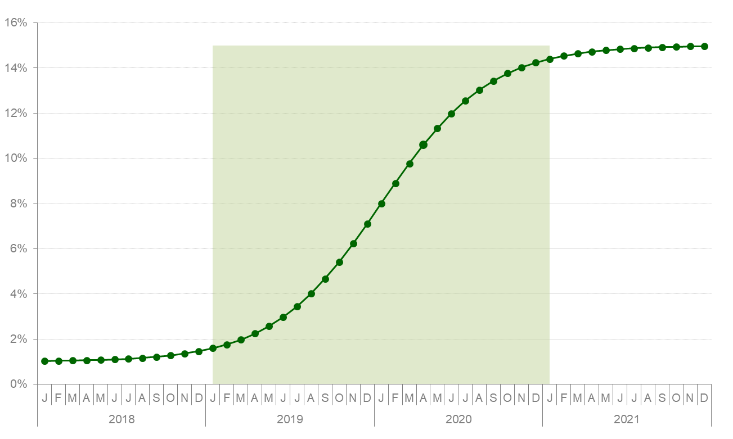

The pro-forma plan without the recommended programs shows per quarter averages for Revenue being $ -332.82 million. This yields a decrease of $ -67.71 million in Net Income, a decrease of $-0.0265 in EPS per quarter, and a $ -2.14 decrease in stock per quarter.

**\*\***The pro-forma plan with the recommended programs shows per quarter averages for Revenue being $ -43.17 million. This yields a decrease of $-9.36 million in Net Income, a decrease of $-0.0037 in EPS per quarter, and a $-0.29 decrease in stock per quarter.**\*\***

**Revenue increase after both programs:** 2019 Q1- 1.98%, Q2- 2.96%, Q3- 4.67%, Q4- 7.10% & 2020 Q1- 9.77%, Q2- 11.99%, Q3- 13.43%, Q4- 14.23%.

**Net Income increase after both programs:** 2019 Q1- 8%, Q2- 9%, Q3- 10.8%, Q4- 13.4%

2020 Q1- 16.2%, Q2- 18.6%, Q3- 20.1%, Q4- 21%.

**Earnings per share(EPS) increase after both programs:** 2019 Q1- 8.8%, Q2- 10.3%, Q3- 11.7%, Q4- 14.4 2020 Q1- 17.3%, Q2- 19.1%, Q3- 20.8%, Q4- 22.5%.

**Stock Price:** 2019 Q1- 8.9%, Q2- 9.9%, Q3- 11.8%, Q4- 14.3% 2020 Q1- 17.2%, Q2- 19.6%, Q3- 21.1%, Q4- 22%.

**Data Appendix**

|  |  |  |  |
| --- | --- | --- | --- |
| Date | **Export: Value Goods**  *XTEXVA01USQ664N* | **Revolving Consumer Credit**  *BOGZ1FL153166100Q* | **P&G Revenue** |
| 3/30/1990 | 100626 | 223520 | 6123.0 |
| 6/29/1990 | 93903.4 | 233653 | 6216.0 |
| 9/28/1990 | 101466.3 | 250909 | 6652.0 |
| 12/31/1990 | 102759.5 | 243907 | 6857.0 |
| 3/29/1991 | 107640.4 | 249675 | 6795.0 |
| 6/28/1991 | 101467.9 | 257752 | 6722.0 |
| 9/30/1991 | 109862.2 | 277089 | 7205.0 |
| 12/31/1991 | 111229 | 263739 | 7507.0 |
| 3/31/1992 | 112984 | 267816 | 7483.0 |
| 6/30/1992 | 107628 | 272158 | 7167.0 |
| 9/30/1992 | 116322 | 292258 | 7879.0 |
| 12/31/1992 | 114027 | 281767 | 7839.0 |
| 3/31/1993 | 117914 | 286864 | 7350.0 |
| 6/30/1993 | 110297 | 298288 | 7365.0 |
| 9/30/1993 | 122854 | 325011 | 7564.0 |
| 12/31/1993 | 120826 | 316400 | 7788.0 |
| 3/31/1994 | 127227 | 331247 | 7441.0 |
| 6/30/1994 | 126573 | 348625 | 7503.0 |
| 9/30/1994 | 138001 | 383187 | 8161.0 |
| 12/30/1994 | 141211 | 381573 | 8467.0 |
| 3/31/1995 | 147056 | 401754 | 8312.0 |
| 6/30/1995 | 143085 | 427090 | 8542.0 |
| 9/29/1995 | 153391 | 464947 | 9027.0 |
| 12/29/1995 | 153831 | 456188 | 9090.0 |
| 3/31/1996 | 157052 | 471729 | 8587.0 |
| 6/30/1996 | 149771 | 484730 | 8580.0 |
| 9/30/1996 | 164418 | 524417 | 8903.0 |
| 12/31/1996 | 164945 | 505699 | 9142.0 |
| 3/31/1997 | 174967 | 513922 | 8771.0 |
| 6/30/1997 | 169041 | 527696 | 8948.0 |
| 9/30/1997 | 180230 | 555533 | 9355.0 |
| 12/31/1997 | 172703 | 535467 | 9641.0 |
| 3/31/1998 | 170341 | 559889 | 8881.0 |
| 6/30/1998 | 160624 | 567097 | 9276.0 |
| 9/30/1998 | 178470 | 597660 | 9510.0 |
| 12/31/1998 | 166604 | 579336 | 9934.0 |
| 3/31/1999 | 171597 | 593009 | 9231.0 |
| 6/30/1999 | 169868 | 604129 | 9450.0 |
| 9/30/1999 | 187729 | 627467 | 9919.0 |
| 12/31/1999 | 187806 | 616812 | 10590.0 |
| 3/31/2000 | 195977 | 636949 | 9783.0 |
| 6/30/2000 | 195675 | 657911 | 9661.0 |
| 9/30/2000 | 202460 | 702247 | 9969.0 |
| 12/31/2000 | 195262 | 694173 | 10180.0 |
| 3/31/2001 | 190279 | 709029 | 9511.0 |
| 6/30/2001 | 169954 | 705033 | 9582.0 |
| 9/30/2001 | 173604 | 735093 | 9766.0 |
| 12/31/2001 | 166456 | 711468 | 10400.0 |
| 3/31/2002 | 177950 | 729216 | 9900.0 |
| 6/30/2002 | 171800 | 741402 | 10170.0 |
| 9/30/2002 | 176895 | 772123 | 10800.0 |
| 12/31/2002 | 174295 | 750644 | 11000.0 |
| 3/31/2003 | 180715 | 759335 | 10660.0 |
| 6/30/2003 | 175920 | 764703 | 10920.0 |
| 9/30/2003 | 193840 | 790388 | 12200.0 |
| 12/31/2003 | 196696 | 768593 | 13220.0 |
| 3/31/2004 | 206132 | 774312 | 13030.0 |
| 6/30/2004 | 201372 | 792724 | 12960.0 |
| 9/30/2004 | 214576 | 824421 | 13740.0 |
| 12/31/2004 | 214723 | 793899 | 14450.0 |
| 3/31/2005 | 230549 | 807870 | 14290.0 |
| 6/30/2005 | 222363 | 818699 | 14260.0 |
| 9/30/2005 | 238341 | 856683 | 14790.0 |
| 12/31/2005 | 244654 | 841578 | 18340.0 |
| 3/31/2006 | 261465 | 859216 | 17250.0 |
| 6/30/2006 | 257659 | 876504 | 17840.0 |
| 9/30/2006 | 272856 | 923877 | 18780.0 |
| 12/31/2006 | 268384 | 892673 | 19720.0 |
| 3/31/2007 | 285489 | 916374 | 18690.0 |
| 6/30/2007 | 287383 | 946115 | 19270.0 |
| 9/30/2007 | 306942 | 1001625 | 20200.0 |
| 12/31/2007 | 314349 | 972523 | 21040.0 |
| 3/31/2008 | 339271 | 983250 | 20030.0 |
| 6/30/2008 | 337012 | 983028 | 20880.0 |
| 9/30/2008 | 296810 | 1003997 | 20980.0 |
| 12/31/2008 | 246348 | 940323 | 19760.0 |
| 3/31/2009 | 251303 | 927383 | 17860.0 |
| 6/30/2009 | 264408 | 916473 | 18080.0 |
| 9/30/2009 | 293984 | 916077 | 19810.0 |
| 12/31/2009 | 296966 | 854314 | 21030.0 |
| 3/31/2010 | 315122 | 841087 | 19180.0 |
| 6/30/2010 | 318547 | 829016 | 18930.0 |
| 9/30/2010 | 347630 | 839103 | 20120.0 |
| 12/31/2010 | 351449 | 791850 | 21350.0 |
| 3/31/2011 | 371160 | 800257 | 19890.0 |
| 6/30/2011 | 374010 | 805280 | 20450.0 |
| 9/30/2011 | 383672 | 840353 | 21530.0 |
| 12/31/2011 | 381714 | 796525 | 21740.0 |
| 3/31/2012 | 391225 | 802591 | 20190.0 |
| 6/30/2012 | 378239 | 808263 | 18540.0 |
| 9/30/2012 | 394525 | 840364 | 20740.0 |
| 12/31/2012 | 383127 | 799694 | 22180.0 |
| 3/31/2013 | 396931 | 813014 | 20600.0 |
| 6/30/2013 | 388229 | 818261 | 16600.0 |
| 9/30/2013 | 410154 | 854664 | 20830.0 |
| 12/31/2013 | 392428 | 814911 | 21100.0 |
| 3/31/2014 | 410506 | 836740 | 19640.0 |
| 6/30/2014 | 404323 | 847389 | 13490.0 |
| 9/30/2014 | 413913 | 888018 | 18770.0 |
| 12/31/2014 | 372781 | 846527 | 18500.0 |
| 3/31/2015 | 387620 | 872913 | 16930.0 |
| 6/30/2015 | 371776 | 888888 | 16550.0 |
| 9/30/2015 | 370925 | 906744 | 16530.0 |
| 12/31/2015 | 346814 | 872776 | 16920.0 |
| 3/31/2016 | 363387 | 900647 | 15760.0 |
| 6/30/2016 | 362882 | 916757 | 16100.0 |
| 9/30/2016 | 377939 | 967961 | 16520.0 |
| 12/31/2016 | 372605 | 928477 | 16860.0 |
| 3/31/2017 | 384452 | 953270 | 15600.0 |
| 6/30/2017 | 381666 | 967493 | 16080.0 |
| 9/30/2017 | 407749 | 1022135 | 16650.0 |
| 12/31/2017 | 403054 | 971314 | 17400.0 |
| 3/31/2018 | 428832 | 984192 | 16280.0 |
| 6/30/2018 | 413040 | 1003714 | 16500.0 |
| 9/30/2018 | 421066 | 1053479 | 16690.0 |
| 12/31/2018 | 408509 | 1004846 | 17440.0 |

**References:**

*Households and nonprofit organizations; revolving consumer credit; liability, Level, Millions of Dollars, Quarterly, Not Seasonally Adjusted*

Federal Reserve Economic Data: FRED: St. Louis Fed. Retrieved from [https://fred.stlouisfed.org/](https://fred.stlouisfed.org/BOGZ1FL153166100Q) BOGZ1FL153166100Q

*Exports: Value Goods for the United States, National currency, Monthly Level, Quarterly, in Millions $ Not Seasonally Adjusted*

Federal Reserve Economic Data: FRED: St. Louis Fed. (n.d.). Retrieved from <https://research.stlouisfed.orgfred2/> XTEXVA01USQ664N